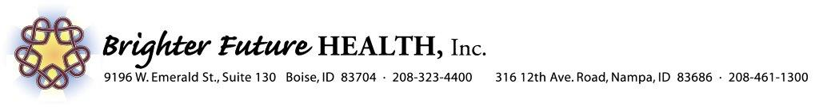 BrighterFutureHealth.com
Referring Agency
Referring Contact/number_______________________________________________________________
Client name _____________________________________________
Insurance/Member ID______________________Client M/F DOB _______________________________
Client address _________________________________________________________________________
Client phone number___________________________________________________________________
Primary Physician
- Has this person received services from other Behavioral Health Agencies? Y or N (Please list Agency)

- Is this person in need of a Language interpreter Circle Y or N Please list language

Please check all services being requested:
CBRS Refugee Specialist CBRS Case Management Groups
Peer Support Counseling Family Support Specialist
We at Brighter Future Health would like to thank you for your referral to our agency. We will be contacting the client within twenty four hours of receiving the referral to schedule a diagnostic assessment. After the assessment, we will create a treatment plan that focuses on the client’s goals and will be contacting Optum for authorization of units. We appreciate any records you may have in assisting with this process. We are happy to accommodate any special requests that you may have and look forward to helping your client in starting a path to a brighter future.
Please Fax Referrals to (208) 343-0787 or Email to Referrals@BrighterFutureHealth.com
Refugee and CBRS Specialists (formerly PSR)-Community Based Rehabilitation services are a cutting edge resource. When participating in CBRS, you receive the benefit of one on one service with one of our highly trained providers. Unlike therapy, CBRS allows providers to enter your home and go into the community with you in order to help you feel comfortable with your surroundings and deal with the stressors you experience. Brighter Future Health has extensive experience in working with the refugee population. We have interpreters that speak many different languages that we work side by side with when serving our clients. All of our providers receive extensive training on customs and traditions as we help refugee families adapt to their new homes. When you feel overwhelmed by your stressors, or simply need assistance in dealing with the situations that arise in life, your CBRS provider will be there to assist you. If you also participate in therapy, CBRS acts to help you take what you have learned from your therapist and apply it at home and in the community.
Peer Support Specialist-Peer Support Specialists support recovery using their own life experiences in managing a mental illness. PSS build a working relationship and promote confidence, reassurance, and hope that recovery is possible with the peers they work within our program. All peers support specialist are certified and receive guidance from our therapists. Our peer support specialists look forward to helping a recovery to a Brighter Future.
Case Management-We understand the difficulties that come up when you are dealing with your mental health diagnosis. It can appear very difficult to properly care for your mental health when you are having difficulties with income, housing, medical care or other issues with your basis needs. Case management gives you the benefit of having someone there to assist you with those needs so you don’t have to worry about them constantly. As you begin to be assured that your basic needs are being met, you may then focus on finding your path to happiness in life.
Counseling Services-Our therapists focus on your needs by taking time to understand what is important to you. We understand that one size does not fit all when it comes to the emotional stress of life. We strive to understand you and go to great lengths to tailor your therapy to your needs. Our goal is to provide a stress free environment where you can be comfortable both physically and mentally while you are talking about one of our therapists. We do everything possible to help you find your road to success.

Certified Family Support Partners-A CFSP is direct caregiver-to-caregiver support. This support comes from someone who has lived experience raising a child with mental illness, navigating multiple child-serving systems, and assisting the child in developing the resiliency needed for recovery. All family members are affected when someone in the household is living with a healthcare concern, and this is no truer than it is for the parents/guardians raising a child living with a behavioral health challenge. Having this lived experience and sharing it with other parents/caregivers is what the Certified Family Support Partner (CFSP) brings to the table that is different from other helping professionals. A CFSP provides support and inspires hope to families in similar situations. Integration of CFSPs into the workforce is a critical component to a recovery-oriented system of care

